**Memo**

To: Professor Pisano

From: Bailey Brake, Ruohui Huang, Emily Lampat, Khang Le, Yuri Zhang

Team: 9

Date: 3/8/2024

Subject: 2nd Prototype Test Report

# Test Setup

## Bill of Materials:

**Hardware**:

* LED Light: Selected for its efficiency and brightness, which are crucial for our application.
* Arduino Nano Microcontroller: Chosen for its compact size and lack of unnecessary functions, making it ideal for our streamlined prototype.
* Oscilloscope: Essential for accurately measuring the LED's flicker frequency and ensuring our product meets the required specifications.
* Probes/Wires: For connecting and testing the circuit.
* Laptop Computer: Used for programming the Arduino and monitoring the test.
* Tactile Push Buttons: For manual control over the LED's ON/OFF Level.

**Software**:

* Arduino IDE
  + Arduino script to generate 40Hz(±1Hz) light frequency.
  + Take buttons as input to write into LED output, acting as power source

## Setup Procedure:

Our setup has been carefully designed to replicate a natural application environment. We have a pre-test setup and a setup procedure. In order to ensure our test goes seamlessly, we have uploaded the Arduino code onto our Arduino Nano, and have the Nano along with the circuitry board be integrated onto the back of our LED panel. At the front, we have placed the phone holder where the user places their phone and is able to use it.

As for the setup before our prototype test, we simply connect the Arduino Nano into a wall plug as the power source, place a temporary stand so that our LED panel does not have to put it flat onto the table. All of the setup procedures went accordingly to plan, as outlined in our test plan. Below are pictures of how our prototype test setup turned out to be.

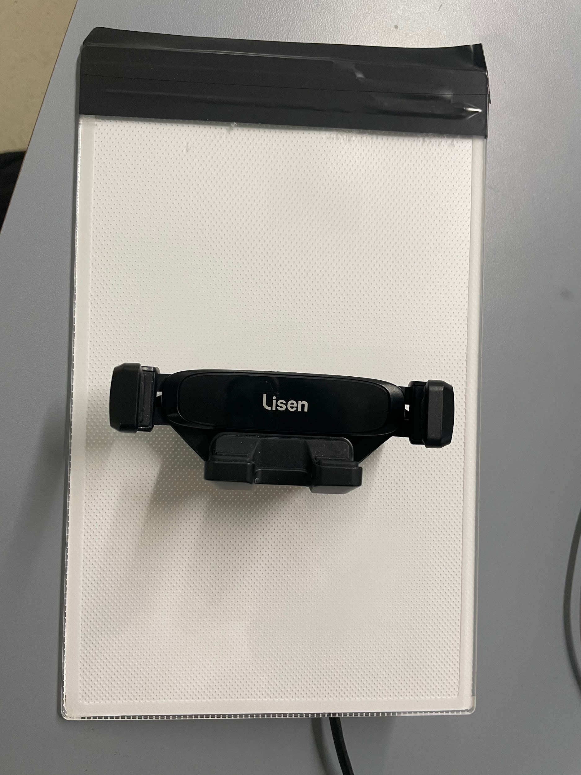

Figure 1. Front of LED Panel T0 Model

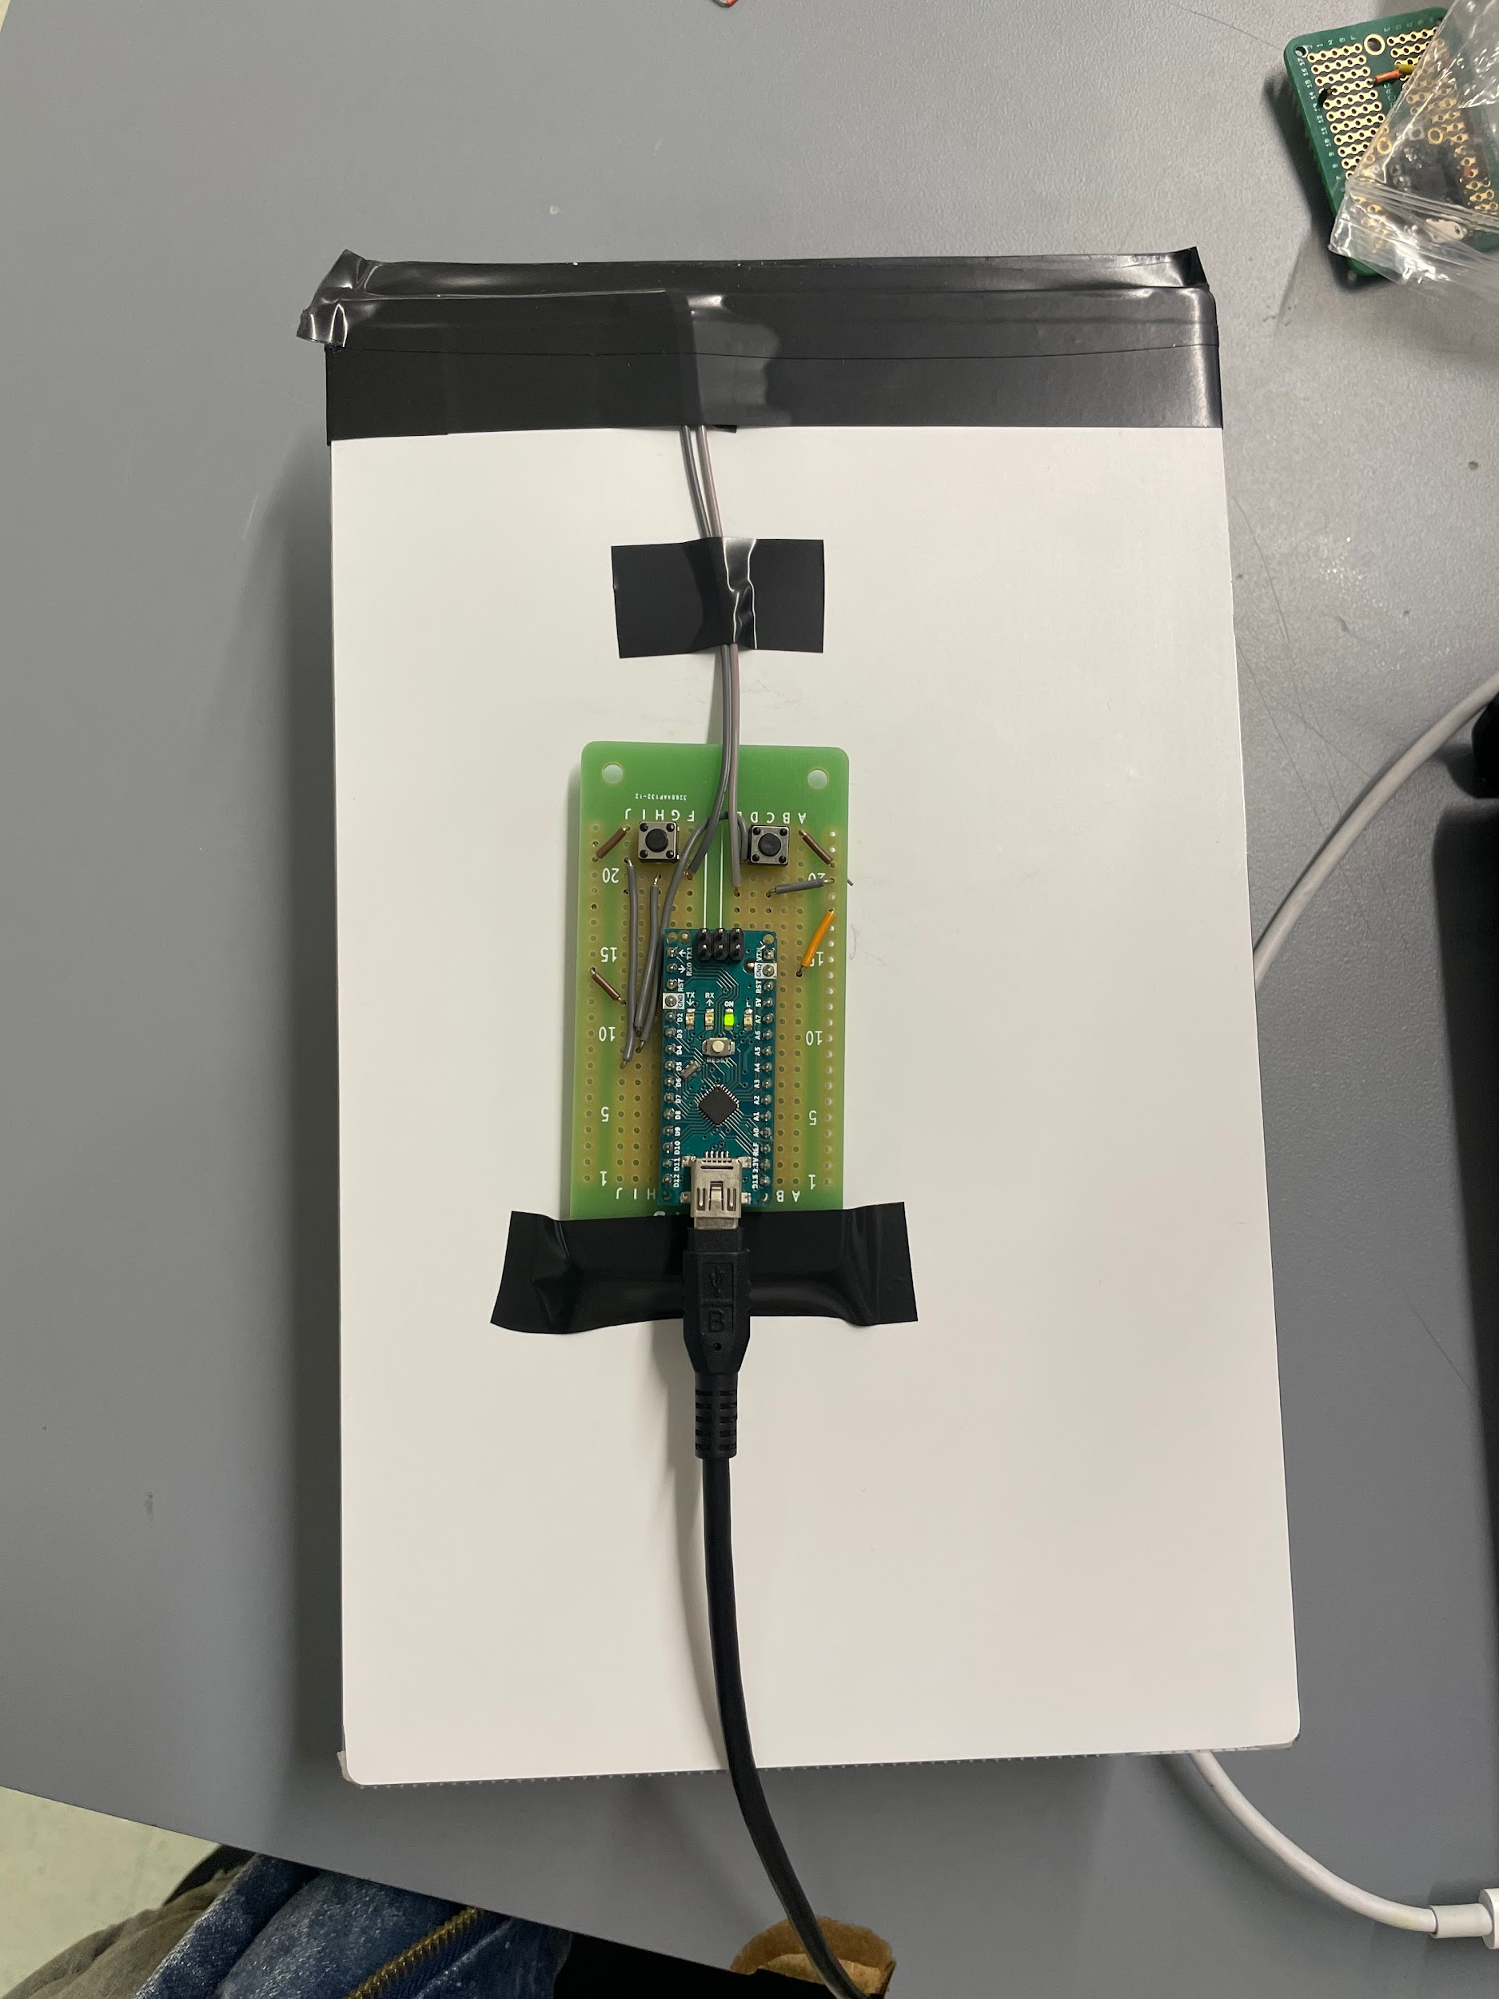

Figure 2. Back of LED Panel T0 Model

# Results and Measurements

## Flicker Frequency Measurement:

In order to measure the flicker frequency, we set a time interval of 25ms on the oscilloscope, which is the desired time period of a flicker, considering we want 40Hz and:

The LED's on-off cycle was observed to be consistent within this timeframe, with a deviation of less than 0.5ms, indicating high precision in frequency control. Below was the result for our flickering rate, where the span that we see at the top was set to be 0.5ms, which encapsulated the cycles of on/off.

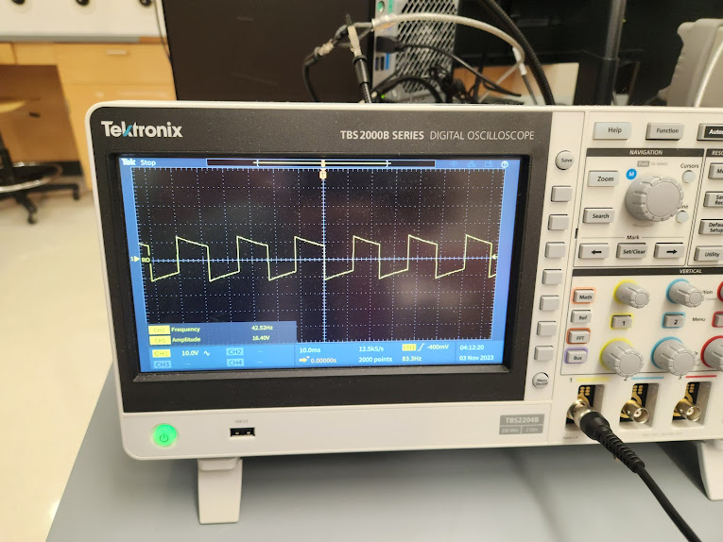

Figure 3. Oscilloscope Reading from T0 model

## ON/OFF Toggle Button Measurement:

For our ON/OFF toggle signal button, we measured how long it takes for the LED flickering to turn off upon a click on the button. We made several measurements with different intervals of the button click, to ensure that our debouncer was working properly and that the signal was being transmitted flawlessly with no delay or latency. The intervals between each toggle consisted of: {2 seconds, 1 second and 50 millisecond} apart. The result was that the LED was able to turn on and off according to the button click well within 1 second.

# Conclusion and In-Depth Analysis

## 3.1 Conclusion:

In conclusion, our decision to only test the T0 model with Professor Hirsch led to success. We were able to prove that our model was functioning at the proper level through observation as well as measurement with an oscilloscope. Our model was bright enough that the user could see the light flickering, even in a well-lit room, and the flickering was visible to the naked eye. Since this was the base model, it only had on/off functions which worked smoothly.

## 3.2 Future Directions:

Our next steps for our project are to continue work on the T9 model. We have the circuit functioning, however, transitioning it to a circuit board from a breadboard has been somewhat difficult since the connections can become unstable. We will also continue with our housing models for both the T0 and the T9 models. Overall, the circuits are presentable, but there is still progress needed on creating two visually appealing and easily understood products.

## 3.3 Reflective Analysis:

The T0 and T9 utilize very similar circuitry, but their forms are different. A successful test of the T0 is a good sign for the T9. Testing the T0 resulted in a clear view of how its form should be improved: for example, the LED panel should be propped up by arms on the housing to provide a simpler user experience. This same testing procedure on the T9 will similarly clarify its form. These sort of conclusions are difficult to quantify, but warrant mentioning, as user experience is crucial to these designs.